Steps to Create AWS S3 bucket

1. Login to AWS
2. Open the services drop down

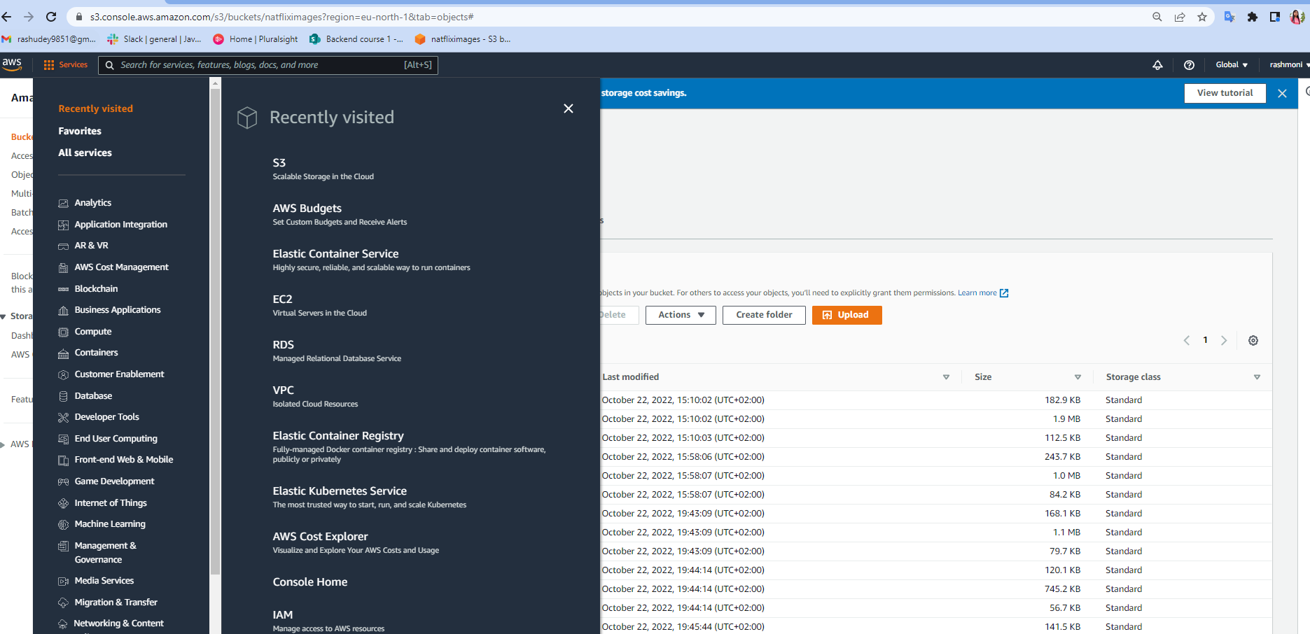

1. Select RDS from services
2. Click on create database

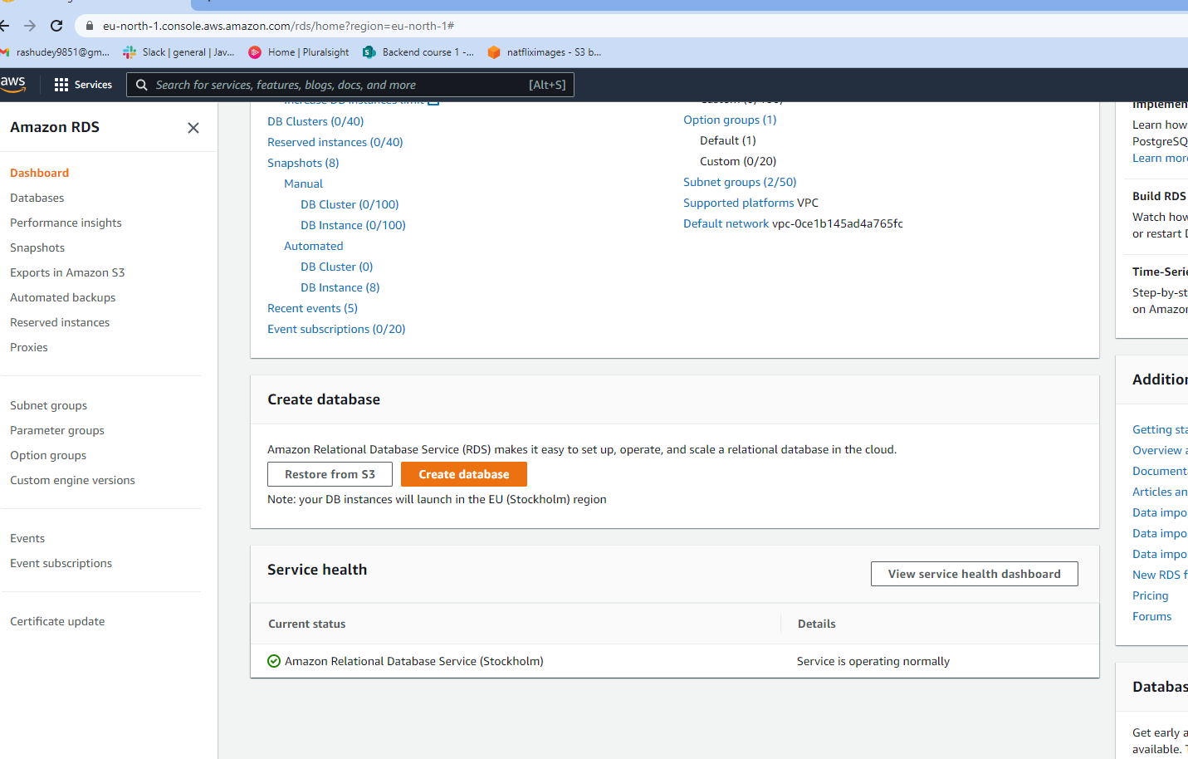

1. Select MySQL and Free Tier

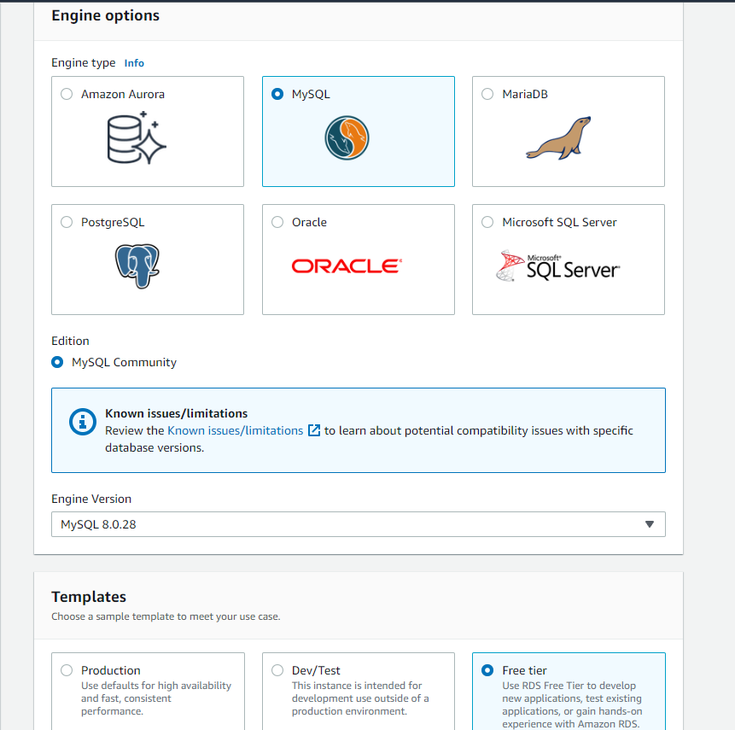

1. Enter the below details

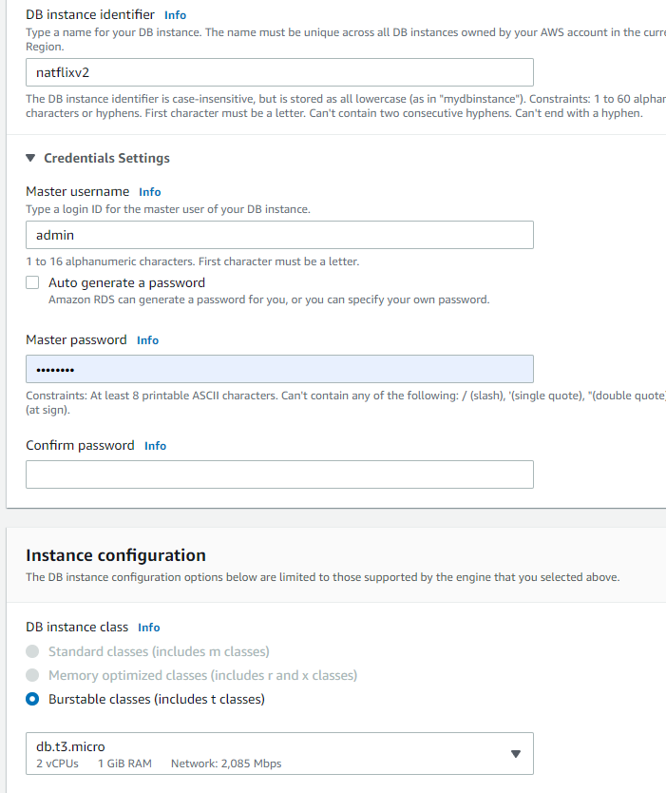

1. Click on create database

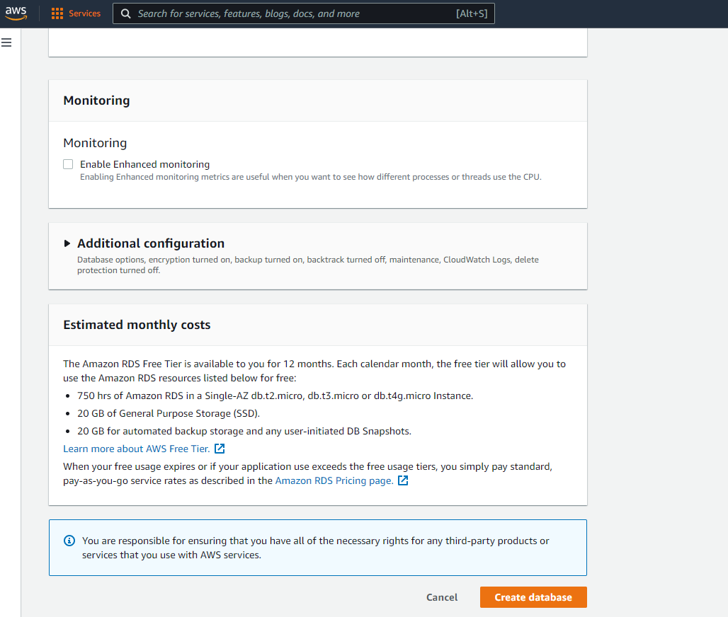

1. Connect to your database using following endpoint and port and the username and password entered during creation

